MAT116

WEEK 9 FINAL EXAMINATION

Name: __________________________ Date: _____________

1. | Graph the inequality.
  y > –4
 | A)
  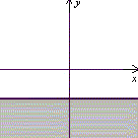
 | B)
  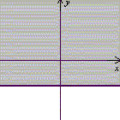
 | C)
  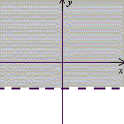
 | D)
  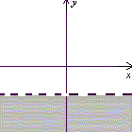

2. | Find the LCM for 12 and 24.
 | A) | 1
 | B) | 12
 | C) | 24
 | D) | 288

3. | Write the following phrase using symbols. Use the variable x to represent the number.  Eight less than three times a number
 | A) | 3(8 – x)
 | B) | 3(x – 8)
 | C) | 3x – 8
 | D) | 8 – 3x

4. | Find for the following set of numbers:
 | A) | 2
 | B) | 1
 | C)
 | D)

5. | Solve. = –10
 | A) | –4
 | B) | 4
 | C) | 25
 | D) | –25

6. | Are the following lines parallel, perpendicular, or neither?  L₁ with equation x – 6y = 12  L₂ with equation 6x + y = 6
 | A) | Parallel
 | B) | Perpendicular
 | C) | Neither

7. | Add. 14 + (–1)
 | A) | 15
 | B) | 13
 | C) | –13
 | D) | –15

8. | Convert 0.4 to a fraction and write the result in lowest terms.
 | A)
 | B)
 | C)
 | D)

9. | Evaluate. (15 – 5) ÷ [(12 ÷ 2 · 2) – 2]
 | A) | 10
 | B) | 1
 | C)
 | D) | 8

10. | The following pie chart represents the eye color of students in a certain class.  If there were 96 students in the class, how many students had brown eyes?
 | A) | 46
 | B) | 47
 | C) | 48
 | D) | 49

11. | Which property of the real numbers is illustrated by the following statement?  6 · 3 = 3 · 6
 | A) | Commutative property of multiplication
 | B) | Associative property of multiplication
 | C) | Distributive property

12. | Evaluate. (–8)² – 15
 | A) | –79
 | B) | –49
 | C) | 49
 | D) | –31

13. | Find the slope and y-intercept.  x = –9
 | A) | Slope: 0; y-intercept: (0, –9)
 | B) | Slope: undefined; y-intercept: (0, –9)
 | C) | Slope: 0; y-intercept: none
 | D) | Slope: undefined; y-intercept: none

14. | Is –4 a solution to the equation 7x – 5 + 3x = 6 + x – 10
 | A) | Yes
 | B) | No

15. | At 1:00 p.m., a car leaves a city and travels north at a rate of 55 mi/h. An hour later, a second car leaves the city and travels south at a rate of 60 mi/hr. At what time will the two cars be 285 miles apart?
 | A) | 2:00 p.m.
 | B) | 3:00 p.m.
 | C) | 4:00 p.m.
 | D) | 5:00 p.m.

16. | Graph 3x + 2y = 6.
 | A) | 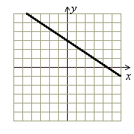
 | B) | 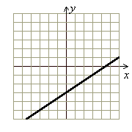
 | C) | 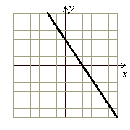
 | D) | 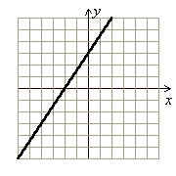

17. | Given f(x) = 2x + 4, find f(a – 4).
 | A) | 2a – 4
 | B) | 2a
 | C) | a + 2
 | D) | a – 4

18. | The sum of two numbers is 32. Their difference is 6. What are the two numbers?

19. | Angus invested $22,000, part at 3% and part at 14%. If the total interest at the end of the year is $990, how much did he invest at 3%?
 | A) | $3,000
 | B) | $20,000
 | C) | $19,000
 | D) | $18,000

20. | Write the equation of the line passing through (1, 0) and (1, –1).
 | A) | x = 1
 | B) | y = 1
 | C) | y = x + 1
 | D) | y = –x

21. | Give the coordinates of the point graphed below.  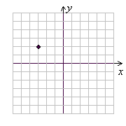
 | A) | (–3, 2)
 | B) | (2, –3)
 | C) | (3, –2)
 | D) | (–2, 3)

22. | Evaluate. | –10 | – | 4 |
 | A) | –14
 | B) | –6
 | C) | 6
 | D) | 14

23. | A television is marked down from $350 to $308. What is the discount rate?
 | A) | 11%
 | B) | 12%
 | C) | 13%
 | D) | 87%

24. | Solve. –3(x + 1) = 2(x – 8) + 3
 | A) | –1
 | B) | 1
 | C) | 3
 | D) | 2

25. | Solve and graph the solution set. 3x ≥ 7x + 20
 | A) | –5 0
 | B) | –5 0
 | C) | 0 5
 | D) | 0 5

26. | Which of the ordered pairs is a solution for the equation 4x – 2y = 8?
 | A) | (0, 4)
 | B) | (–2, 0)
 | C) | (–2, –4)
 | D) | (0, –4)

27. | Multiply.  6v⁹ ⋅ 10v⁷
 | A) | 16v¹⁶
 | B) | 16v⁶³
 | C) | 60v⁶³
 | D) | 60v¹⁶

28. | Combine like terms.  8p + q + 6p
 | A) | 14p + q
 | B) | 15pq
 | C) | 9p + 6q
 | D) | 15p + q

29. | Solve the following system of linear inequalities by graphing.  x + 2y ≤ 3  2x – 3y ≤ 6
 | A) | 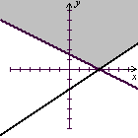
 | B) | 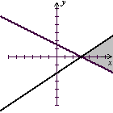
 | C) | 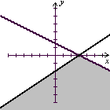
 | D) | 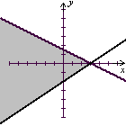

30. | Find the slope of the line passing through the points (3, –5) and (3, 2).
 | A) | 0
 | B) | 1
 | C) | 7
 | D) | Undefined

31. | Divide. Write the result in simplest form.
 | A)
 | B)
 | C)
 | D)

32. | One number is 12 more than another. The sum of the smaller number and twice the larger number is 39. Find the larger number.
 | A) | 5
 | B) | 7
 | C) | 17
 | D) | 34

